
PATUAKHALI SCIENCE AND TECHNOLOGY UNIVERSITY

COURSE CODE CCE 312
Numerical Methods Sessional

SUBMITTED TO:

Prof. Dr. Md Samsuzzaman

Department of Computer and Communication Engineering
Faculty of Computer Science and Engineering

SUBMITTED BY:
Md. Sharafat Karim
ID: 2102024,
Registration No: 10151
Faculty of Computer Science and Engineering

Assignment 16
Assignment title: Newton Rapson Method
Date of submission: 08 Wed, Oct 2025

Problem Statement
Background:
A pharmacodynamics research team is modeling the concentration of a new heart medication in the bloodstream over time. The drug's effectiveness is directly related to its steady-state concentration, where the rate of administration equals the rate of elimination. The model for the steady-state concentration C (in mg/L) is derived from a nonlinear pharmacokinetic equation.
The Challenge:
After simplifying the complex biological model, the team arrives at the following equation that must be solved for the steady-state concentration C:
C²−2=0
This equation is transcendental and cannot be solved analytically for an exact solution. The team needs a numerical value for C to determine if the concentration falls within the therapeutic window (the range where the drug is effective but not toxic).

Code
# Our function
def f(x):
return x**2 - 2

def df(x):
return 2*x

# Newton-Raphson Method
def newton_raphson_method(f, df, x0, tol=1e-5, max_iter=100):
x = x0
for i in range(max_iter):
x_new = x - f(x) / df(x)
if abs(x_new - x) < tol:
return x_new
x = x_new
raise ValueError(
"Newton-Raphson method did not converge within the maximum number of iterations."
)

root = newton_raphson_method(f, df, 1)
print(root)

root = newton_raphson_method(f, df, 10)

# Let's plot the result
x = np.arange(0, 3, 0.1)
plt.plot(x, f(x), label='f(x) = x^2 - 2')
plt.scatter(root, f(root), color='blue') # Mark the root on the plot
plt.axvline(root, color='purple', linestyle='--', label=f'x = root ({root:.5f})')
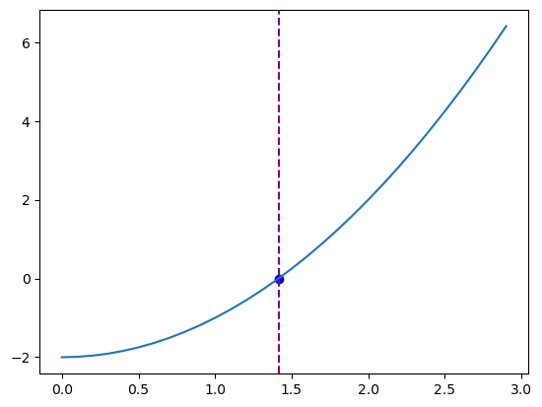
Visualization

